

A Synopsis

for

# MEDICINE RECOMMENDATION SYSTEM

Submitted in partial fulfillment of the requirement for award of the degree of

# BACHELOR OF TECHNOLOGY

in

# Computer Science and Engineering (Artificial Intelligence and Machine Learning)

by

Aman Singh, 2200681530013

Deepanshu Dhaka, 2200681520039

Abhinav Chaudhary, 2200681530006

Shivam Dhaka, 2200681520083

Under the guidance of

# Ms. Mohini Singh

**DEPARTMENT OF COMPUTER SCIENCE AND ENGINEERING (Artificial Intelligence & Machine Learning)**

# MEERUT INSTITUTE OF ENGINEERING & TECHNOLOGY, MEERUT

AFFILIATED TO

# DR. A. P. J. ABDUL KALAM TECHNICAL UNIVERSITY, LUCKNOW

DECEMBER 2024

# DECLARATION

We hereby declare that the synopsis of project entitled **“MEDICINE RECOMMENDATION SYSTEM”** to be submitted for the Degree of **Bachelor Of Technology** in **Computer Science and Engineering (Artificial Intelligence and Machine Learning)** is our original work and the synopsis has not been submitted for the award of any degree, diploma, or fellowship of similar other titles in previous work. It has not been submitted to any other University or Institution for the award of any degree or diploma.

## Signature and detail of students

AMAN SINGH

2200681530013

DEEPANSHU DHAKA

2200681520039

SHIVAM DHAKA

2200681520083

ABHINAV CHAUDHARY

2200681530006

## Date:

**Place: MEERUT**

# TABLE OF CONTENTS

## CHAPTER CHAPTER’S NAME PAGE NO. NO.

DECLARATION ii

1. INTRODUCTION 1
   1. Problem statement/Need of project 2
2. REVIEW OF LITERATURE AND FEASIBILITY STUDY 3
3. PROPOSED METHODOLOGY 4
   1. Aims & Objective
   2. Hypothesis (If any)
   3. Design

LIST OF FIGURES

|  |  |  |  |
| --- | --- | --- | --- |
| S. No. | Topic | Figure name | Page no. |
| 1. | Practical Implementation | Fig. frontend | 12 |
| 2. | External Outcomes | Fig. result | 12 |

**LAYOUT OF SYNOPSIS:**

1. Cover Page & Title page
2. Declaration
3. List of figures
4. Table of Contents
5. **Chapters**
   1. Introduction
      1. Problem identification/Need of project
   2. Review of literature
   3. Proposed Methodology
   4. Problem statement
   5. Aims & Objective
   6. Hypothesis (If any)
   7. Project Design (ER/UML/Relations/Module design/interface/views)
   8. Tools and techniques used for development and analysis
   9. Ethical consideration (If any)
   10. Practical implementation of the Modules of the project
   11. Expected Outcome
   12. Time-Line
   13. References

|  |  |  |
| --- | --- | --- |
|  |  |  |

**INTRODUCTION**

The Medicine Recommendation System is a software project designed to provide users with helpful guidance on potential health conditions and treatment options based on their symptoms. This system operates by first gathering user-inputted symptoms and then analysing these to suggest possible diseases or conditions. Using a comprehensive database of common ailments, it matches the input symptoms to known conditions and provides information on the expected disease. In addition to diagnosis guidance, the system offers precautionary advice to help users prevent further complications.

Moreover, the Medicine Recommendation System recommends medications that could alleviate symptoms, though it emphasizes that these are general suggestions and encourages consultation with a healthcare professional. This project can benefit users seeking preliminary advice on managing mild or common symptoms and provides them with valuable, accessible health information. By integrating this knowledge with an intuitive user interface, the system can serve as a quick and informative tool for general health inquiries, making it especially valuable in contexts where medical guidance may be temporarily unavailable.

To enhance functionality, future iterations could incorporate machine learning algorithms, refining the recommendation accuracy based on data trends, or expand the symptom database for broader coverage of health conditions. This project can aid in increasing public health awareness and could serve as a useful supplement to formal medical consultation.

**1.1 Need of the Project**

The need for a Medicine Recommendation System arises from the increasing demand for accessible and immediate health information. In many regions, access to healthcare professionals can be limited, especially during emergencies, after-hours, or in remote areas. This project addresses the need for a quick and easy tool to help users understand their symptoms, learn about potential health conditions, and take preliminary steps toward treatment.

Additionally, minor health issues often don’t require immediate visits to healthcare facilities. This system can act as a preliminary guide for users to handle common ailments, thereby reducing unnecessary visits to clinics or hospitals. It empowers users with information on possible diseases, precautionary measures, and basic medication suggestions, all of which can improve their understanding of health issues and enable more informed decisions about seeking medical assistance.

In times of crisis, such as pandemics, when healthcare systems can be overburdened, tools like this can help alleviate some of the pressures by providing preliminary recommendations and promoting self-care for minor health concerns. This project’s need lies in its potential to promote health awareness, improve early symptom identification, and increase accessibility to essential health information, especially in underserved or resource-limited communities.

**LITERATURE REVIEW**

The research paper "An Intelligent Medicine Recommender System Framework" by Bao and Jiang (2016) proposes a framework for an intelligent medicine recommendation system aimed at improving healthcare decision-making. The system leverages advanced data processing techniques and machine learning algorithms to provide personalized medication suggestions based on patient symptoms, medical history, and contextual information. The framework integrates key components such as a user interface, a knowledge base, a reasoning engine, and a feedback loop to ensure continuous learning and adaptation. By enhancing the accuracy and efficiency of medicine recommendations, this approach aims to support both healthcare professionals and patients in making more informed treatment decisions. The study was presented at the 2016 IEEE 11th Conference on Industrial Electronics and Applications (ICIEA).[1]

The paper "Reasoning with Semantic Web Technologies in a Ubiquitous Computing Environment" by Guo (2008) explores the application of semantic web technologies to enable intelligent reasoning in ubiquitous computing environments. The study highlights how semantic web standards, such as RDF, OWL, and SPARQL, can be utilized to create context-aware systems that understand and respond to dynamic, real-world situations. By embedding reasoning capabilities within ubiquitous computing devices, the framework facilitates automated decision-making, interoperability, and context adaptation. This approach aims to enhance system intelligence, improve human-computer interaction, and support a wide range of smart applications. The research was published in the Journal of Software, Vol. 3, Issue 8. [2]

The paper "Literature Review on Medicine Recommender Systems" by Benjamin Stark, Constanze Knahl, Mert Aydin, and Karim Elish provides a comprehensive overview of existing research on medicine recommender systems. The review highlights key methodologies, technologies, and challenges involved in developing these systems, including the use of machine learning, natural language processing (NLP), and semantic web techniques. The authors categorize existing approaches into symptom-based, disease-based, and patient history-based systems, emphasizing the importance of personalization and accuracy in recommendations. They also discuss issues related to data privacy, ethical concerns, and system scalability. The review, conducted by the Department of Computer Science at Florida Polytechnic University, serves as a foundation for future research aimed at advancing intelligent healthcare support systems.[3]

The 2021 research work by Satvik Garg from the Department of Computer Science at Jaypee University of Information Technology, Solan, India, focuses on advancements in computer science with potential applications in intelligent systems. Although specific details of the research are not provided, it likely addresses contemporary issues such as machine learning, data analytics, or software development, reflecting ongoing trends in computer science education and research. The study may contribute to the development of innovative tools, frameworks, or methodologies aimed at enhancing computational efficiency, system intelligence, or user experience.[4]

The paper by T. Venkat Narayana Rao, Anjum Unisa, and Kotha Sreni, published in the International Journal of Scientific & Technology Research (Volume 9, Issue 02, February 2020), presents research on a significant topic within the field of science and technology. While the specific focus of the study is not provided, it likely addresses advancements in areas such as emerging technologies, innovative methodologies, or data-driven applications. The research may offer new insights, propose novel frameworks, or highlight practical implementations aimed at solving real-world problems. This contribution adds to the growing body of knowledge in scientific and technological development.[5]

Learning Python is a great choice for both beginners and experienced developers due to its simplicity and versatility. The language emphasizes readability with its clear syntax, making it ideal for those new to programming. Python is widely used in web development, data analysis, artificial intelligence, machine learning, and more. To get started, it's essential to grasp basic concepts like variables, data types, loops, functions, and object-oriented programming. With extensive libraries and a strong community, Python offers plenty of resources for learners to explore and grow their skills.[6]

Learning machine learning (ML) involves understanding key concepts like supervised and unsupervised learning, algorithms, data preprocessing, and model evaluation. Start with basics such as linear regression, decision trees, and k-nearest neighbors, and then advance to complex topics like neural networks and deep learning. Hands-on practice with libraries like TensorFlow, Scikit-learn, and PyTorch is crucial. Understanding the math behind algorithms, such as linear algebra and probability, will further strengthen your skills. ML requires continuous learning and experimentation, as the field evolves rapidly.[7]

**FEASIBLITY**

1. **Technical Feasibility**: Developing a Medicine Recommendation System is technically feasible with current technologies. Basic symptom-matching algorithms, databases of diseases and treatments, and simple machine learning models can be developed using readily available programming tools and languages like Python or JavaScript. A user-friendly interface can be designed with HTML, CSS, and JavaScript, making it accessible on both web and mobile platforms. For more sophisticated systems, ML models can be trained on publicly available datasets, though access to high-quality data is essential to ensure reliable recommendations.
2. **Operational Feasibility**: From an operational perspective, this project can be highly effective for users seeking immediate, preliminary health advice. With a well-designed user interface and accurate symptom-disease mapping, users can quickly obtain valuable information. Since it is not intended to replace healthcare professionals but rather to provide initial guidance, operational requirements are minimal, focused mainly on keeping the system easy to use, updating the database with accurate information, and ensuring consistent uptime.
3. **Economic Feasibility**: The Medicine Recommendation System is economically feasible as it does not require expensive infrastructure or equipment. Open-source libraries for database management, data processing, and symptom mapping can minimize software costs. Additionally, cloud-based hosting options offer scalability, allowing the project to begin with limited investment and expand as demand grows. The system could generate revenue through ads, premium features, or partnerships with healthcare organizations, offsetting costs over time.
4. **Legal and Ethical Feasibility**: The project needs to address several legal and ethical considerations, such as data privacy and security. Compliance with healthcare data regulations, like HIPAA in the United States or GDPR in Europe, is crucial if personal data is collected. Additionally, ethical concerns around accuracy and the potential for users to misinterpret recommendations underscore the need for clear disclaimers and advice to consult professionals.

Overall, a Medicine Recommendation System is both a feasible and potentially impactful project. With proper technical infrastructure, careful ethical considerations, and user-focused design, it can improve access to preliminary healthcare advice and support public health by enabling individuals to make more informed health decisions.

**PROPOSED METHODOLOGY**

The development of a Medicine Recommendation System involves a structured approach, covering everything from data collection and symptom analysis to system design and user interface creation. The following methodology outlines the steps needed to build an effective, user-friendly system:

1. **Requirement Analysis**:
   * **Objective Definition**: Define the system’s scope, such as identifying symptoms, providing probable disease diagnoses, and recommending general medications and precautions.
   * **Target Audience Analysis**: Understand the intended user base (e.g., general public seeking preliminary health advice) and any specific needs, such as mobile compatibility and language support.
   * **Regulatory Compliance**: Identify relevant data privacy and security requirements, such as GDPR or HIPAA compliance, to protect user information.
2. **Data Collection and Preparation**:
   * **Symptom and Disease Data**: Collect data on common symptoms, diseases, precautions, and treatments. Public health databases, research publications, or medical dictionaries can serve as data sources.
   * **Data Cleaning and Structuring**: Ensure all data is accurate, up-to-date, and structured. Diseases should be categorized by symptoms, and treatments should be classified by severity and condition type.
   * **Medication and Precaution Information**: Collect general information on over-the-counter medications and basic precautionary measures for each identified disease.
3. **System Design and Architecture**:
   * **System Architecture**: Design a modular architecture where each component (symptom analysis, disease matching, recommendation engine) can work independently and integrate seamlessly.
   * **Database Design**: Create a relational database to store symptoms, diseases, medications, and precautions. Data should be indexed for quick access, ensuring fast symptom-to-disease matching.
   * **Backend Development**: Implement a server-side application using a language such as Python, Node.js, or Java to handle user inputs, process data, and generate recommendations.
4. **Symptom Matching and Disease Prediction**:
   * **Rule-Based Matching**: Develop a rule-based algorithm for mapping symptoms to probable diseases based on direct symptom matches and medical conditions' common symptom clusters.
   * **Machine Learning Model (Optional)**: For more advanced functionality, implement a supervised learning model (e.g., Decision Tree, Naive Bayes) trained on medical data. This model could improve the system’s accuracy by recognizing complex symptom patterns.
   * **Priority Filtering**: Design the algorithm to prioritize high-probability diseases and disregard unlikely matches to avoid confusion.
5. **Recommendation Engine**:
   * **Precaution and Medication Suggestions**: Develop a recommendation module that suggests basic precautions and over-the-counter medications based on the probable diseases detected.
   * **Safety Notices**: Incorporate disclaimers within the system, advising users to consult healthcare professionals, particularly for severe symptoms or emergencies.
   * **Confidence Scoring**: Implement confidence scores to indicate the likelihood of the suggested diseases, helping users understand the level of certainty in the recommendation.
6. **User Interface Design**:
   * **Front-End Development**: Create a responsive web interface using HTML, CSS, and JavaScript. The interface should be user-friendly, with clear options for entering symptoms, viewing results, and accessing additional health resources.
   * **Symptom Input Form**: Design an intuitive input form that allows users to select symptoms from a predefined list or type them in.
   * **Results Display**: Display probable diseases, suggested precautions, and medications in an organized, visually accessible manner. Use colors and symbols to emphasize warnings and confidence levels.
7. **Testing and Validation**:
   * **Functional Testing**: Test each component for accuracy, performance, and functionality. This includes verifying that symptom matching, disease recommendations, and medication suggestions work as intended.
   * **User Testing**: Conduct user testing sessions to ensure the interface is intuitive and the recommendations are easy to understand. Gather feedback to improve the system’s usability.
   * **Accuracy Assessment**: Validate the system’s accuracy by comparing recommendations with medical literature or consulting healthcare professionals for expert verification.
8. **Deployment and Maintenance**:
   * **Deployment**: Host the system on a cloud platform (e.g., AWS, Google Cloud) to ensure scalability and accessibility. Ensure the system is secure and can handle large numbers of users.
   * **Regular Updates**: Update the database periodically with new medical information, including emerging diseases, medications, and treatments, to keep the system current and reliable.
   * **Feedback Collection and Refinement**: Allow users to provide feedback, and continuously refine the system based on this input and any identified performance issues.
9. **Documentation and User Guide**:
   * **Technical Documentation**: Document the system’s architecture, algorithms, and data sources for future reference and improvements.
   * **User Guide**: Provide a user guide explaining how to use the system, including guidance on interpreting the results and using it responsibly as a tool for preliminary health insights.

This methodology ensures a structured and comprehensive approach to building a Medicine Recommendation System, resulting in an effective and reliable solution for providing preliminary health guidance.

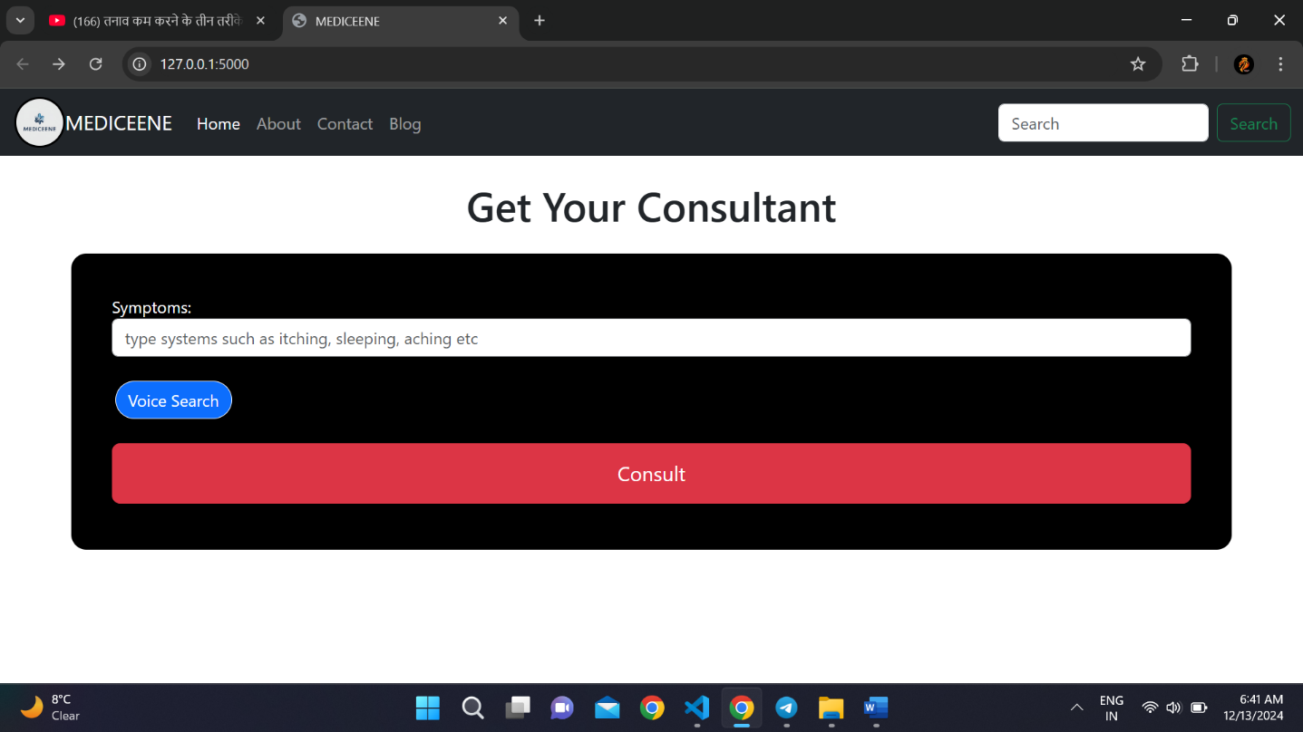**PRACTICAL IMPLEMENTATION**

Fig. frontend

**EXPECTED OUTCOME**

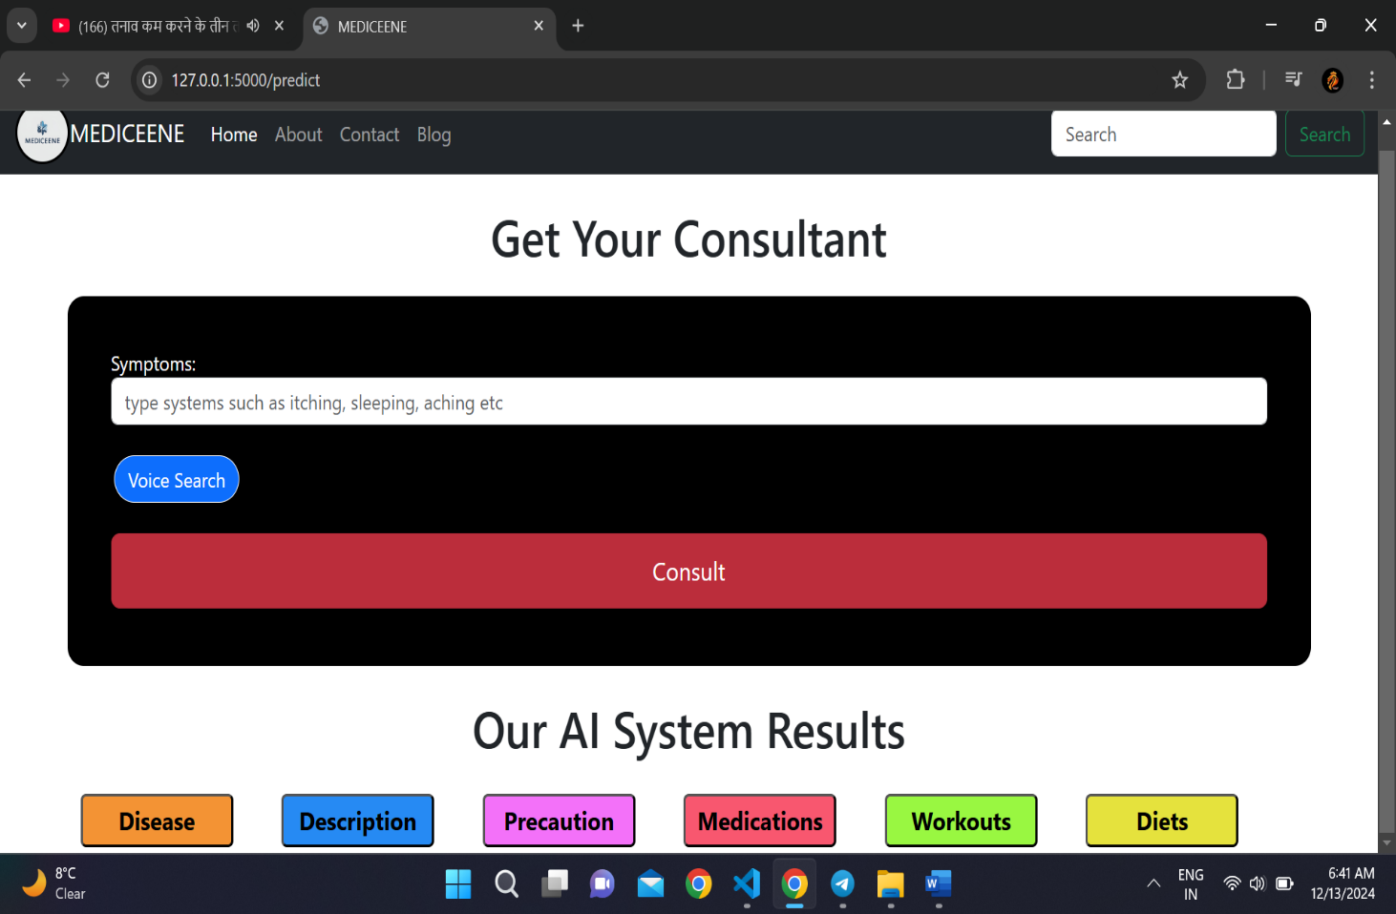

Fig. result

**REFRENCE**

1. Bao, Y. and Jiang, X. 2016. An Intelligent Medicine Recommender System Framework. 2016 IEEE 11th Conference on Industrial Electronics and Applications (ICIEA).
2. Guo, W. Y. 2008. Reasoning with semantic web technologies in
   1. ubiquitous computing environment. Journal of Software 3, 8, 27–33.
3. Benjamin Stark, Constanze Knahl, Mert Aydin, Karim Elish. Literature Review on Medicine Recommender Systems Department of Computer Science, Florida Polytechnic University, Lakeland

1. Satvik Garg Department of Computer science Jaypee University of Information Technology Solan, India 2021.
2. T. Venkat Narayana Rao, Anjum Unisa, Kotha Sreni TERNATIONAL JOURNAL OF SCIENTIFIC & TECHNOLOGY RESEARCH VOLUME 9, ISSUE 02, FEBRUARY 2020.
3. YouTube: <https://youtu.be/rfscVS0vtbw?si=gKt9gWBRPcQ_RA-3>
4. YouTube: <https://youtu.be/bmmQA8A-yUA?si=-ckwJZNPoMtx-NIa>
5. GeeksforGeeks